# OSPF设计实验报告

## 实验要求

1) 整个设计的说明  
    2) 列出基本配置：IP、VLAN  
    3) OSPF的基本配置  
    4) 路由备份配置：OSPF、静态路由等  
    5) 实验验证截图

## 设计说明

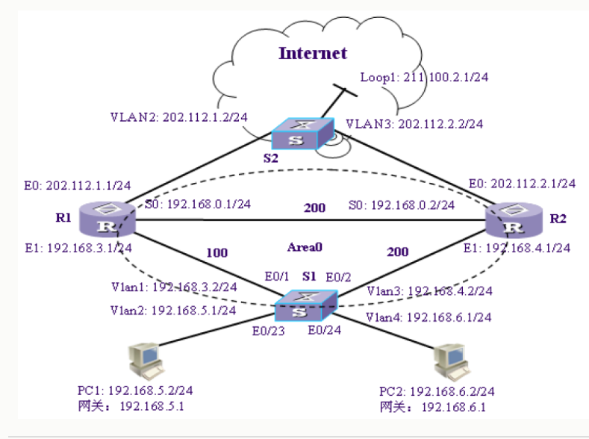

1. R1、R2和S1所组成的网络运行OSPF协议实现互联，对用户PC1和PC2提供访问互联网的服务。通过为各条连线设置不同的花费值，可以使所有的PC通过指定路径访问互联网。
2. 动态路由协议能够自动发现路由，生成路由表。动态路由协议的特性决定了它也可以用于链路备份。在一个到达目的地具有冗余路径的网络中，根据动态路由协议的原理，动态路由协议会把发现的最佳到达目的地的路由添加到路由表中，如果由于某种原因，这条最佳路由出现问题而被删除，那么动态路由协议会重新计算到达目的地的路由，这时就会使用动态路由协议重新计算得到的次优路由到达目的地，从而保证网络不会出现长时间中断，达到备份的目的。若S1-R1路径出现故障，路由协议会自动选取S1-R2-Internet作为新的路径，保持网络畅通。若R2-Internet也发生故障，则将S1-R2-RI-Internet作为新的路径。

## 基本配置

|  |  |
| --- | --- |
| S2 | interface Vlan-interface2  ip address 202.112.1.2 255.255.255.0  #  interface Vlan-interface3  ip address 202.112.2.2 255.255.255.0  #  interface LoopBack1  ip address 211.100.2.1 255.255.255.0 |
| R1 | #  interface Ethernet0/0  ip address 202.112.1.1 255.255.255.0  #  interface Ethernet0/1  ip address 192.168.3.1 255.255.255.0  #  interface Serial0/0  ip address 192.168.0.1 255.255.255.0 |
| R2 | #  interface Ethernet0/0  ip address 202.112.2.1 255.255.255.0  #  interface Ethernet0/1  ip address 192.168.4.1 255.255.255.0  #  interface Serial0/0  ip address 192.168.0.2 255.255.255.0 |
| S1 | #  vlan 1  #  vlan 2  #  vlan 3  #  vlan 4  #  interface Vlan-interface1  ip address 192.168.3.2 255.255.255.0  #  interface Vlan-interface2  ip address 192.168.5.1 255.255.255.0  #  interface Vlan-interface3  ip address 192.168.4.2 255.255.255.0  #  interface Vlan-interface4  ip address 192.168.6.1 255.255.255.0 |

## OSPF基本配置

|  |  |
| --- | --- |
| S1 | #  ospf 1  area 0.0.0.0  network 192.168.3.0 0.0.0.255  network 192.168.4.0 0.0.0.255  #  interface Vlan-interface1  ip address 192.168.3.2 255.255.255.0  ospf cost 100  #  interface Vlan-interface3  ip address 192.168.4.2 255.255.255.0  ospf cost 200 |
| R1 | ospf 1  area 0.0.0.0  network 192.168.0.0 0.0.0.255  network 192.168.3.0 0.0.0.255  #  interface Ethernet0/1  ip address 192.168.3.1 255.255.255.0  ospf cost 100  #  interface Serial0/0  clock DTECLK1  link-protocol ppp  ip address 192.168.0.1 255.255.255.0  ospf cost 200 |
| R2 | ospf 1  area 0.0.0.0  network 192.168.0.0 0.0.0.255  network 192.168.4.0 0.0.0.255  #  interface Ethernet0/1  ip address 192.168.4.1 255.255.255.0  ospf cost 200  #  interface Serial0/0  link-protocol ppp  ip address 192.168.0.2 255.255.255.0  ospf cost 200 |

## 路由备份配置：OSPF、静态路由

|  |  |
| --- | --- |
| R2 | [R2]ip route-static 211.100.2.1 255.255.255.0 202.112.2.2  [R2]ospf  [R2-ospf-1]import-route static cost 100  [R2-ospf-1]import-route direct cost 100 |
| R1 | [R1]ip route-static 211.100.2.1 255.255.255.0 202.112.1.2  [R1]ospf  [R1-ospf-1]import-route static cost 100  [R1-ospf-1]import-route direct cost 100 |
| S2 | [S2]ip route 192.168.0.0 255.255.0.0 202.112.1.1 preference 50  [S2]ip route 192.168.0.0 255.255.0.0 202.112.2.1 preference 60 |
| S1 | [S1]ospf  [S1-ospf]import-route direct |

## 实验验证

在S1-R1路径正常时，PC通过S1-R1-Internet路径访问互联网，出现故障时，路由协议会自动选取S1-R2-Internet作为新的路径，保持网络畅通。

